ZH WIFI Control Card Manual

I. Software Download. 1
(1) . PC Software 1
(2) . Mobile Phone APP 1
II. Mobile Phone APP Sending. 3
1. Choose Language 3
2. WiFi Connection 3
3. ScreenSet 4
(1) . LineType 5
(2) . Width and Height 5
(3) . OEType and DataType 6
(4) . Color 6
(5) . Scan Frequency and Disappear Time 7
4. Subtitle Edition 7
5. Send Data 7
III. PC Software Sending. 8
1. Choose Language 8
2. WiFi Connection 8
3. Display Setting 9
(1) . Entrance of display setting 9
(2) . Model 10
(3) . Width and Height 11
(4) . Quick 12
(5) . OE Polarity and Data Polarity 13
(6) . Color Mode 13
(7) . Communication Mode 14
4. Subtitle Edition 14
(1) . Subtitle(Single Line) 14
(2) . Picture Text(Multi-line) 17
(3) . Partition 18
(4) . Time 19
(5) . Dial 20
(6) . Preview 21
(7) . Temperature 22
(8) . Program 23
5. Sending Data 23
IV. Common Problem 24

Software Download.
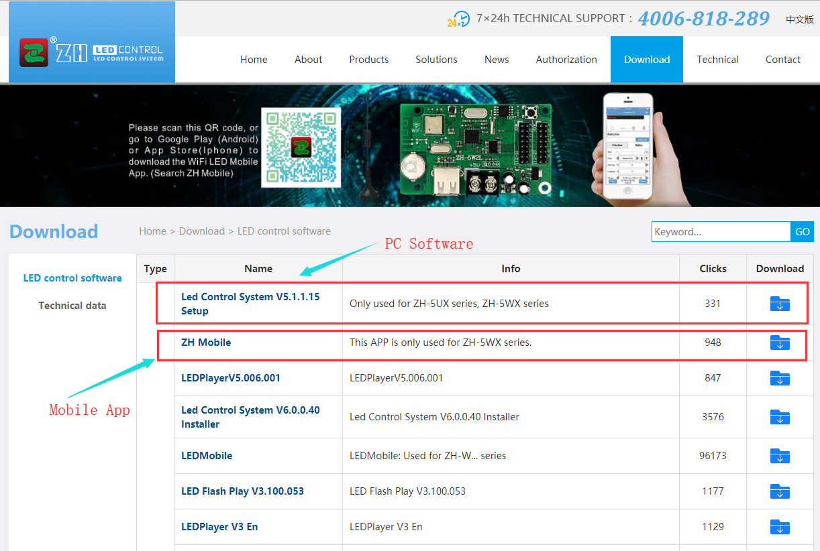

. PC Software
- . Download Website: www.zhonghangled.com/en.
- . Software Name: LED Control System V5.1.1.15.

. Mobile Phone APP : APP Name: ZH Mobile
- . Andorid :
Method 1: search “ZH Mobile” to download in the Play Store;
Method 2: download “ZH Mobile” from the official website:
www.zhonghangled.com/en
Method 3: download it from the following link or scan the QR code and open it in the browser.
Link: www.zhonghangled.com/en/downloadWIFI.asp
- .IOS.
Method 1: search “ZH Mobile” to download in the App store;
Method 2: download it from the following link or scan the QR code and open it in the browser.
Link: www.zhonghangled.com/en/downloadWIFI.asp
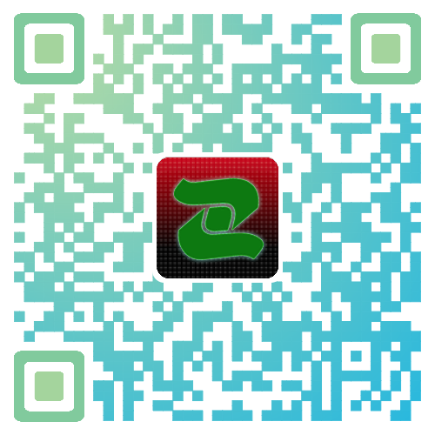

Mobile Phone APP Sending.

Choose Language
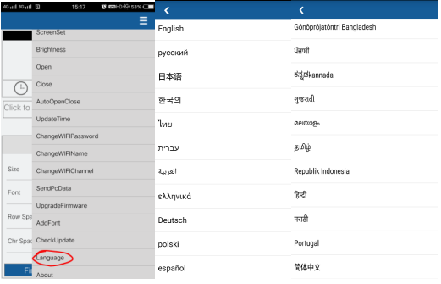

WiFi Connection
You should first open your WLAN setting and connect the “ZH-5W” WiFi signal. The password is 12345678.
Open your APP, click “Find”, then the WiFi will be connected successfully.
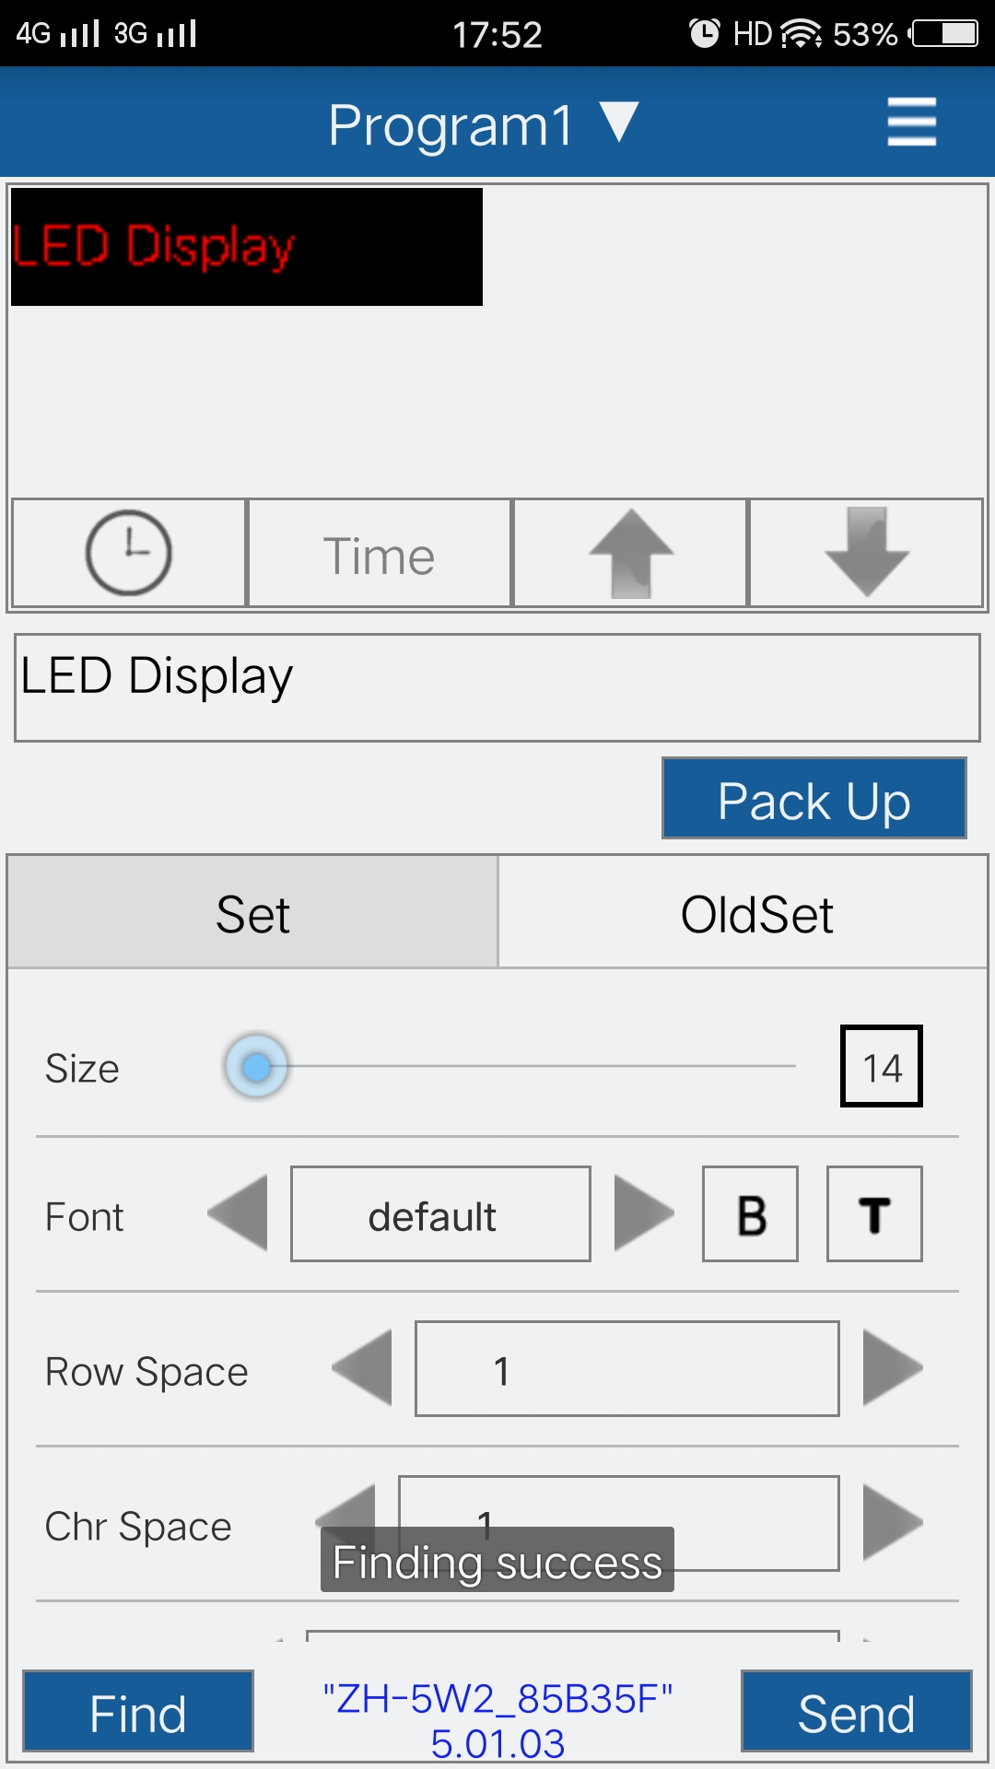

ScreenSet
After that, please click top right corner menu icon, then click “ScreenSet”.
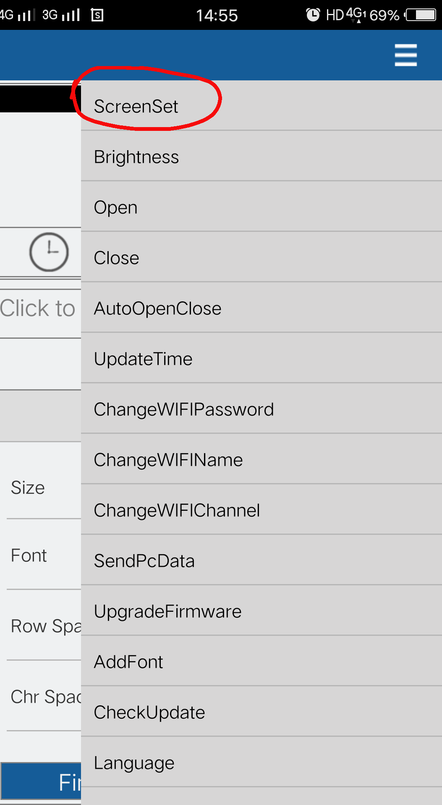

. LineType
Choose your display type in the “LineType” area.
If your display is P10, please choose “General P10”.
If your display is indoor F3.75 or F5, please choose “Within Conventional Household”

. Width and Height
Choose the correct “Width” and “Height”.
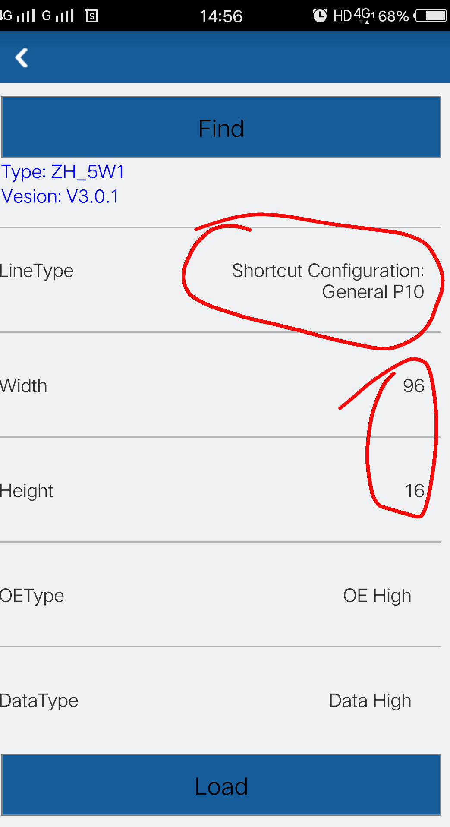

. OEType and DataType
After you change the “LineType”, please keep “OEType” and “DataType” default.
However, if your display happens full light appearance, please change the OEType; if your display happens reverse appearance, please change the “DataType”.

. Color
Please choose the right color according to your LED display color.

. Scan Frequency and Disappear Time
Please keep “Scan Frequency” and “Disappear Time” default.
After you finish ScreenSet, please click “Load”.

Subtitle Edition
You can type some texts, change the size, font, row space, word space, color, special effect, speed, stop time, and border.
You can set time, dial and build more programs.

Send Data
Click “Send” to send all data to your LED display.

PC Software Sending.

Choose Language
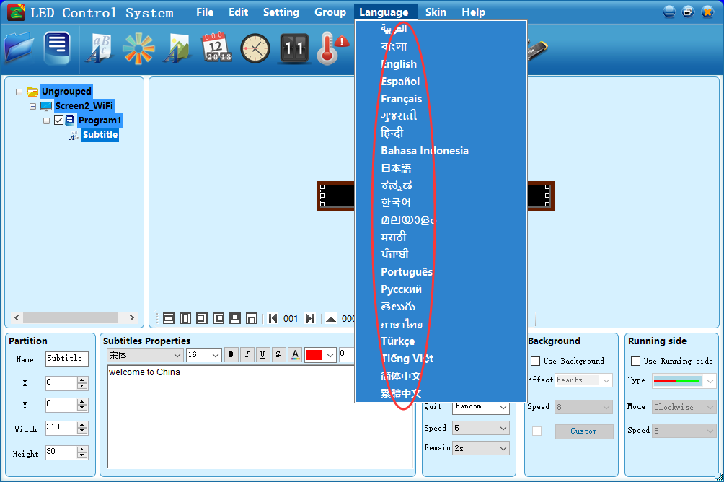

WiFi Connection
You should first open your WLAN setting and connect the “ZH-5W” WiFi signal. The password is 12345678.
Open the software, click the WiFi icon, the WiFi signal will be there, if it is not there, please click “refresh”. And then click “Connect”. The WiFi will be connected successfully.
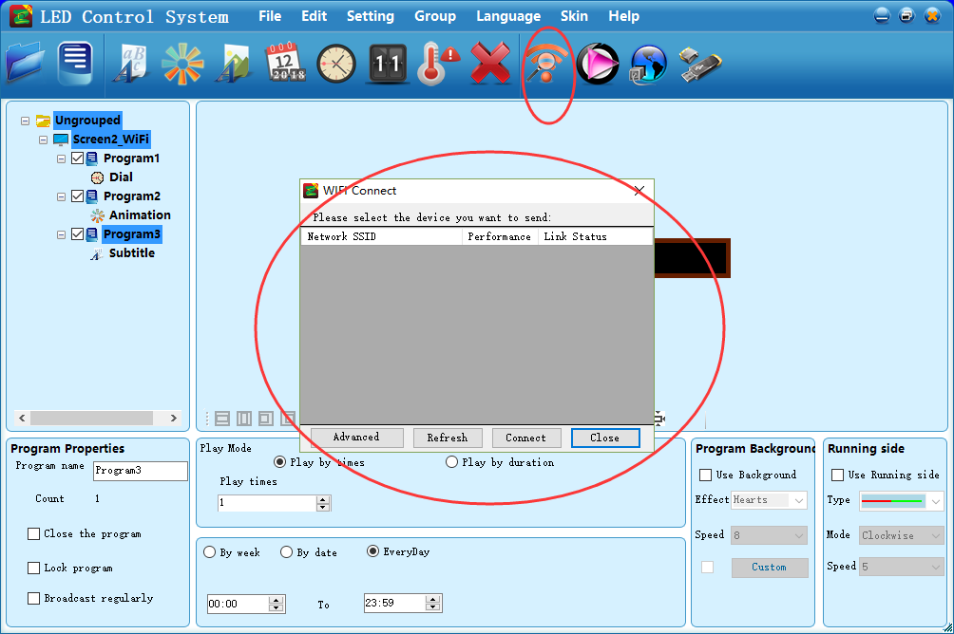

Display Setting

. Entrance of display setting
Click “Setting”, then click “Display setting”, the password is 168.
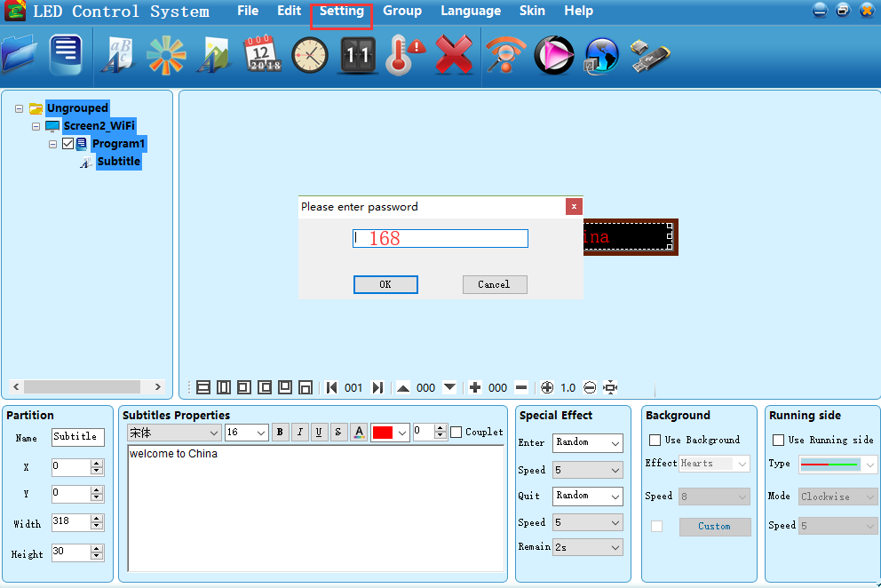

. Model
Please choose your controller model. The controller model is printed on the controller card. If you don’t know, you can open your display and check it or ask your supplier.
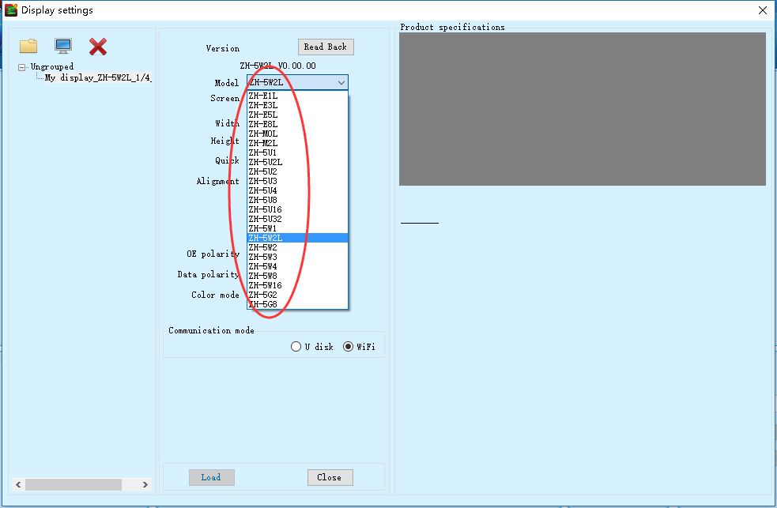

. Width and Height
Please fill the correct display pixel size in the width and height.
If you don’t know it, you can count the quantity of lamp beads in width and height or ask your supplier.
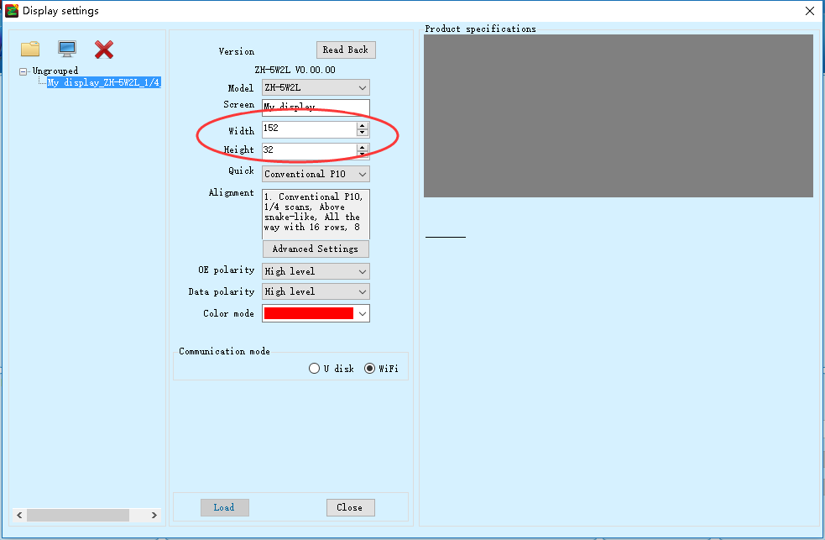

. Quick
If your display is P10, please choose “Conventional P10” in the “Quick”.
If your display is indoor dual color F3.75 or F5, please choose “General Indoor” in the “Quick”.
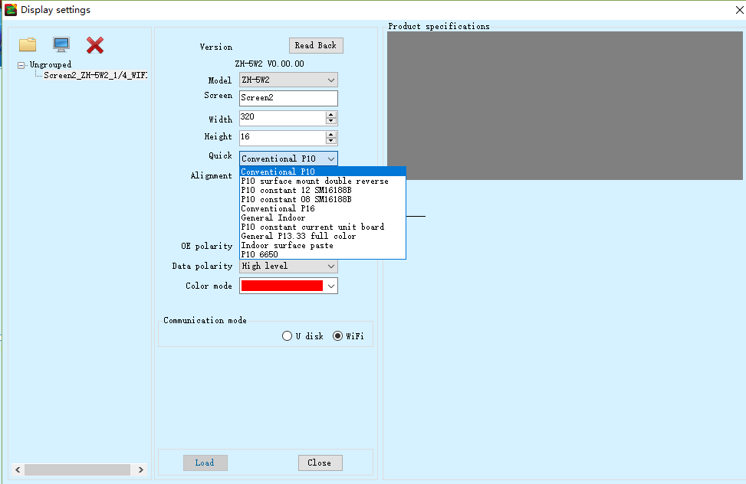

. OE Polarity and Data Polarity
After you change the “Quick”, please keep “OE Polarity” and “Data Polarity” default.
However, if your display happens full light appearance, please change the OE Polarity; if your display happens reverse appearance, please change the “Data Polarity”.

. Color Mode
Please choose the right color according to your LED display color.
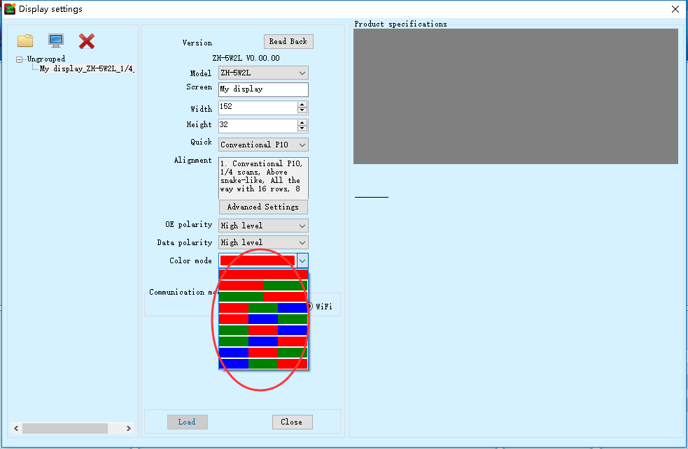

. Communication Mode
If you use WiFi, please choose WiFi.
If you use U disk, please choose U Disk.

Subtitle Edition

. Subtitle(Single Line)
If you only want to display single line, you can click “Subtitle”. Please click extension to full height and full width.
Then you can edit some texts in the text edition area.
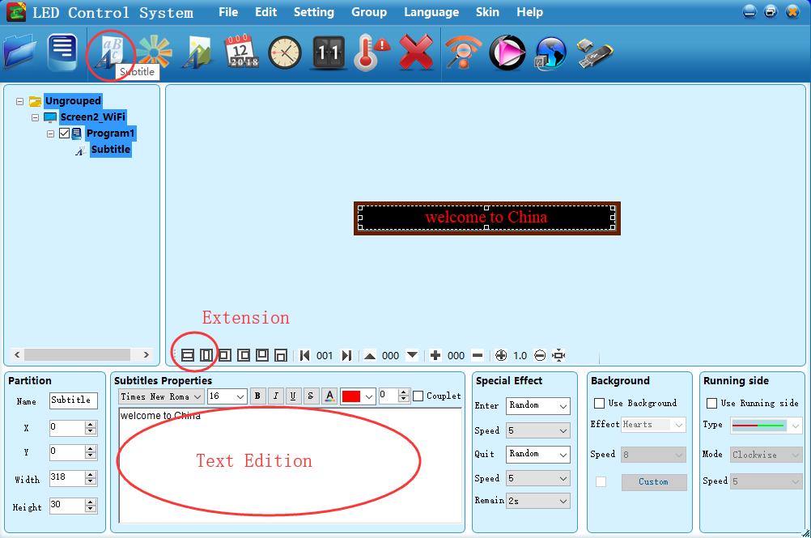
You can change the effect and speed of ‘enter’ and ‘quit’ in the “Special Effect” area. In the speed option, “1” is the fastest.
If you need running side, you can select it in the “Running side” area.
If you need background, you can select it in the “Background” area.
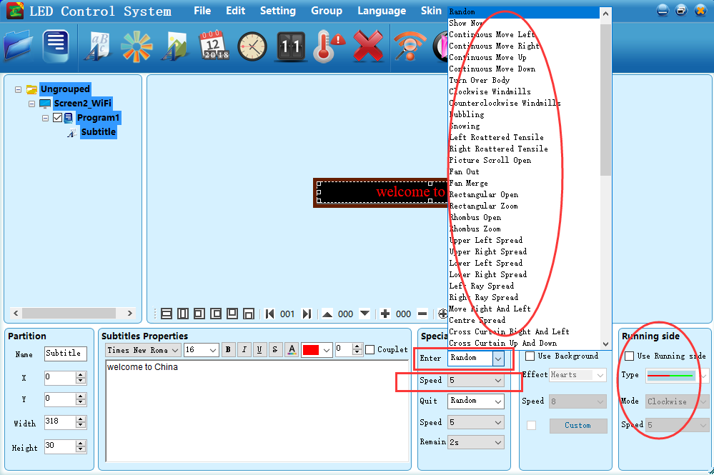
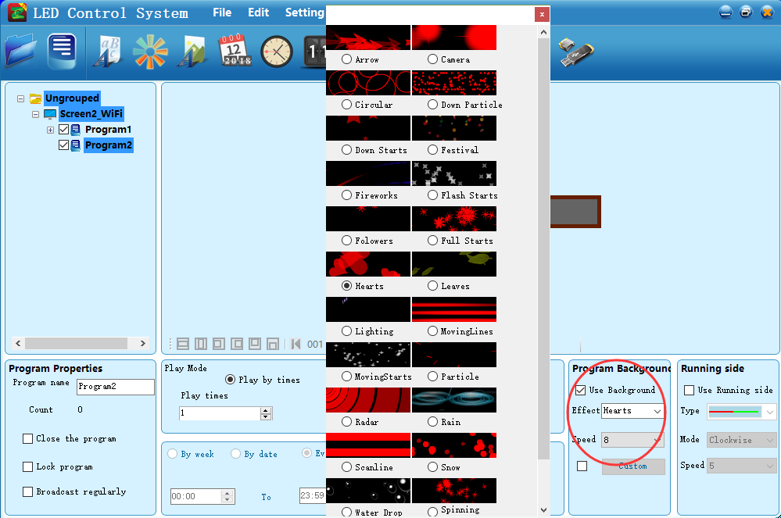

. Picture Text(Multi-line)
You can click “Multi-line” to open the multi-line text edition area.
Meanwhile, you can use animation and form. You can also import your own animation, picture, word or excel.

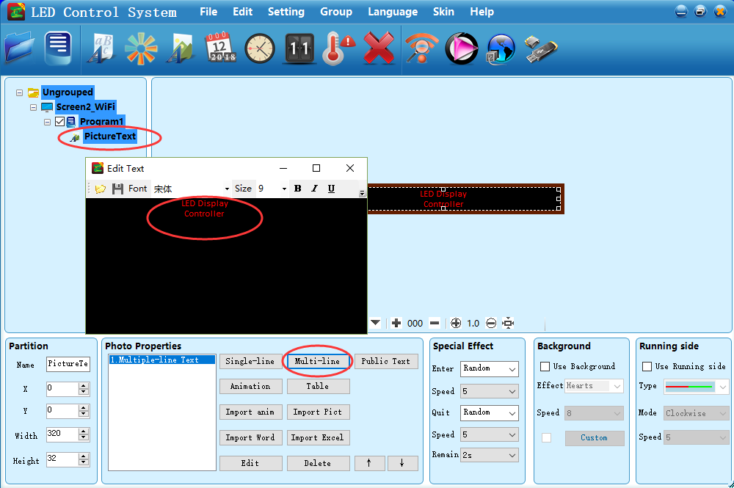

. Partition
You can add several partitions in the screen, like time, subtitle, picture-text, dial and so on.
Please remember not to make them overlap.
The maximum number of partition is 16 pieces.

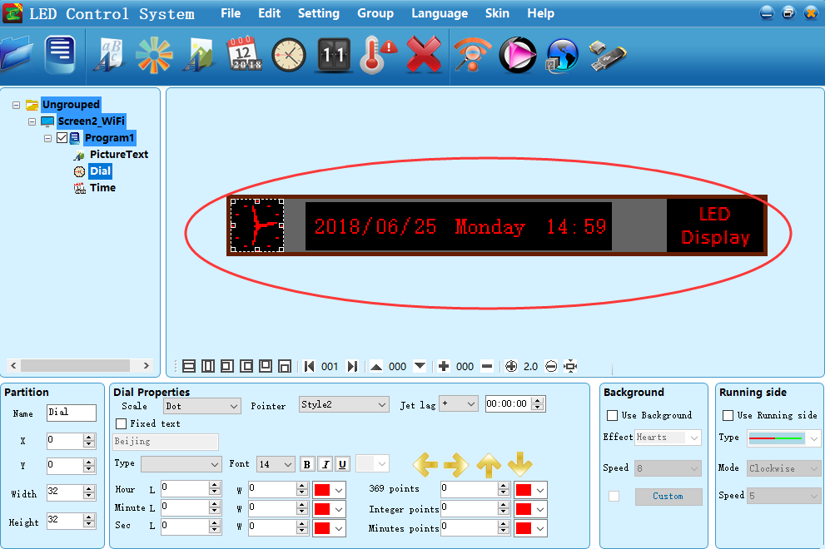

. Time
Click “Time” icon, then you can add time to display. You can choose single line display or multi-line display.
Before you send the data, please click “Calibration Time” in “Setting” to correct the time.
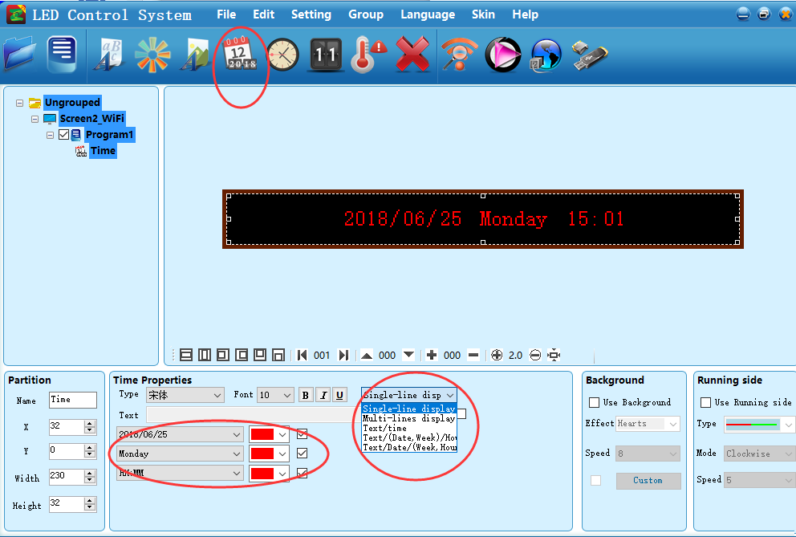
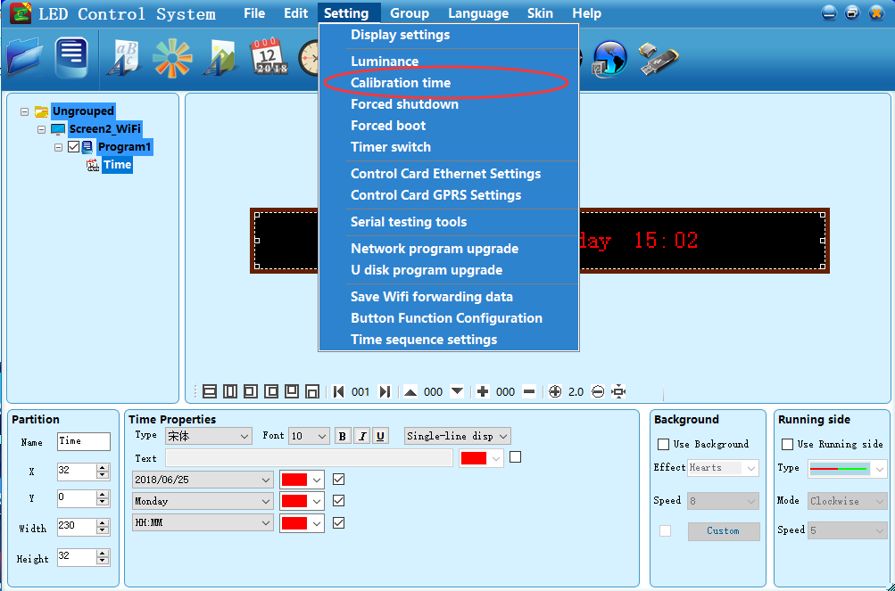

. Dial
Click “Dial” to set the dial clock. You can select the dial shape, fix the text and set Jet Lag for different time, like Beijing, New Delhi, Jakarta, etc.
Before you send to U disk, please click “Calibration Time” in “Setting” to correct the time.
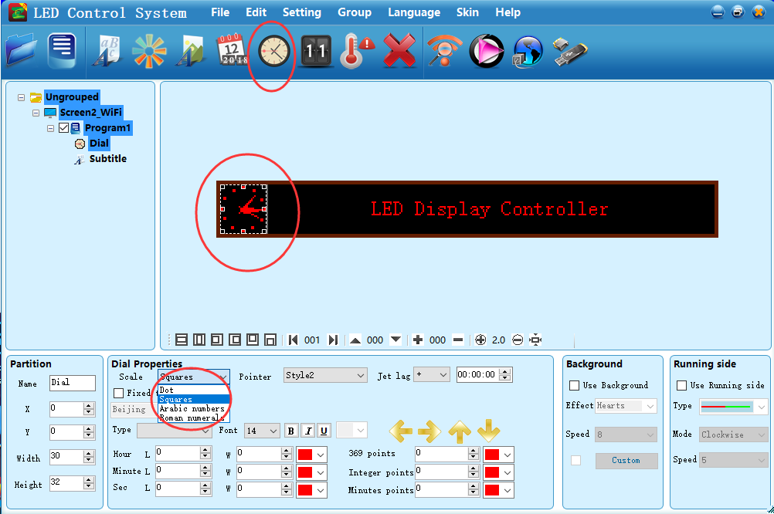

. Preview
Click “Preview” icon. Then a virtual screen will jump out and you can click “+” to see it through bigger size.
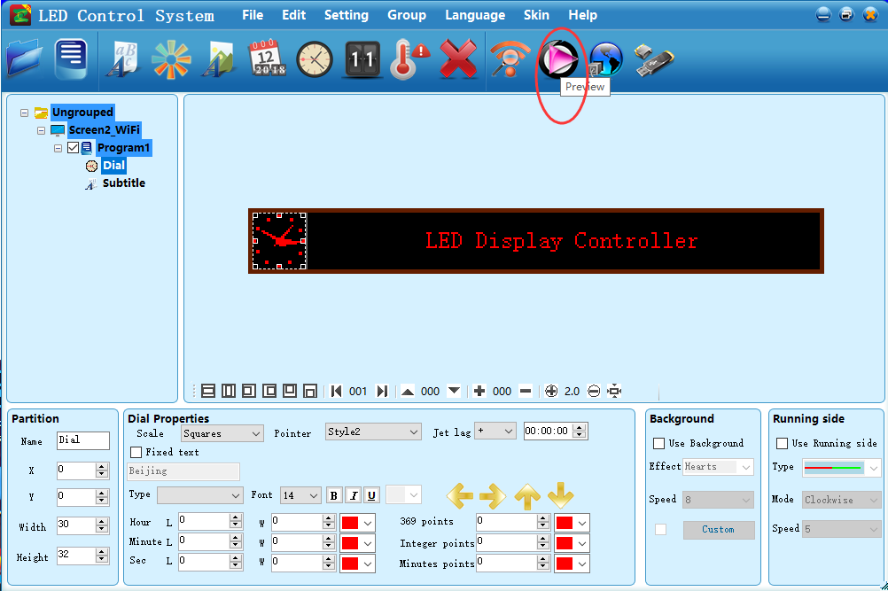
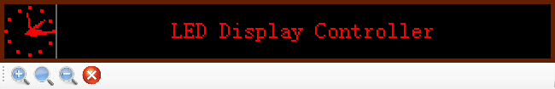

. Temperature
Temperature Sensor Model: DS18B20.
“5V” connects with the red wire of sensor; “S” connects with the yellow wire of sensor; “G” connects with the black wire of sensor.
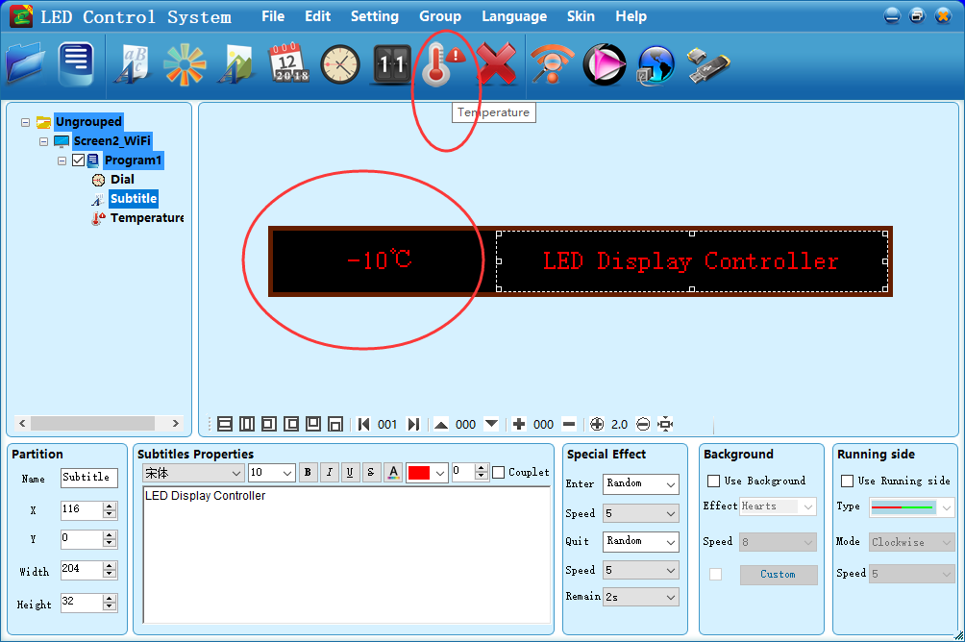
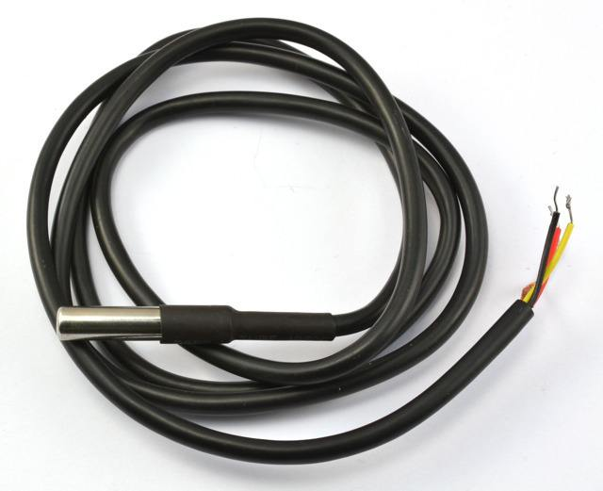

. Program
If you need, you can click “Program” icon add more programs, like program 1, program 2, program 3, etc.
If you need, you can also set program play duration for different program so that your screen will display different things in different time.
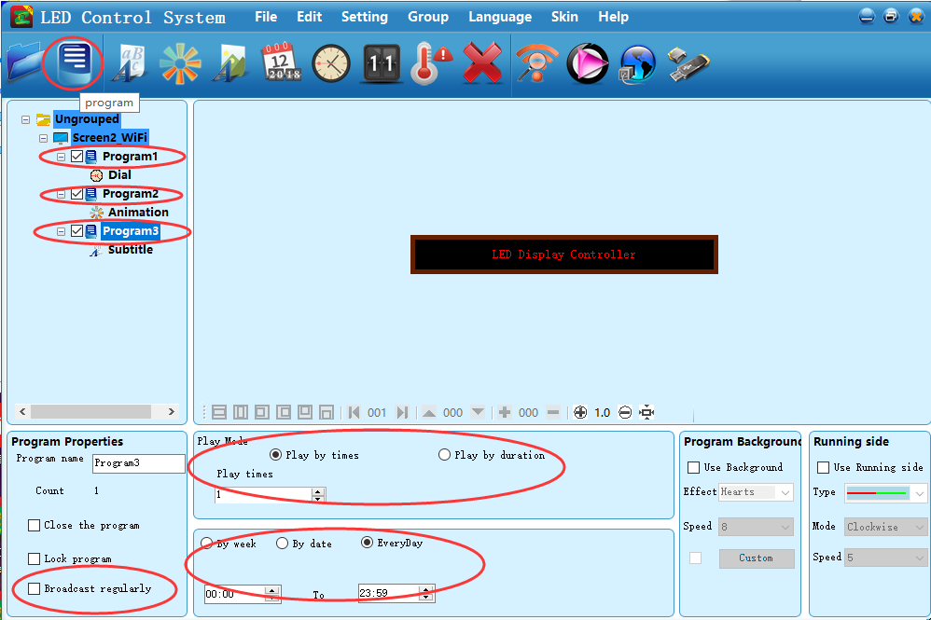

Sending Data
If you use WiFi to communicate, you can click “Send” icon.
If you use U disk to communicate, you can click “U Disk” icon.

IV. Common Problem
- How many mobile phones can connect the WiFi signal at the same time?
Answer: For security reasons, we allow four devices to connect simultaneously.
- What can you do if you can’t find the WiFi signal in the WiFi setting?
Because the software will automatically open the WIFI, some security software will prompt whether you allow the operation, if you choose to ban, this will happen. If users install safe bodyguard APP or other app in the mobile phone, please find the corresponding protection settings, and make sure the software is changed to trust.
- What can you do if you have connected the WiFi, but can’t find WiFi signal in PC software?
1. Click “Refresh”
2. The computer must be set into automatically access to IP address.
Way to set automatically access to IP address.
Open network and sharing center -- Wireless network connection -- Attributes --Internet protocol version 4(TCP/IPv4) attributes --Automatically obtain the IP.
- What can you do if you can’t download the software by scanning QR code in WeChat?
Click the top right corner on the download software page and select “open it in the browser”, you would be able to download software there.

